Assignment 10: Functions

1. You are given the class GraphingFormulas.java as a start.
2. Read through the code and run the program. Why do all the answers come out to zero?
3. Edit the slope and distance formulas so that they compute the slope and distance correctly.
   1. Remember the formula for slope using points (*x*1, *y*1) and (*x*2, *y*2) is

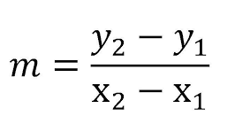

* 1. Remember the formula for distance using points (*x*1, *y*1) and (*x*2, *y*2) is



* 1. You may need these functions:
     1. Math.pow(n1, n2) raises n1 to the n2 power

For example, Math.pow(5,2) gives 5 squared which is 25.

* + 1. Math.sqrt(n) gives the square root of n

For example, Math.sqrt(49) gives 7.

1. For a bonus, make a third function that is void but prints out the formula for the line between the two given points in y=mx+b form. You should call your slope function inside of this function. Then, add 2 test statements for this function in the main part of the program.
2. Run the program and make sure it works as expected.
3. Save the program in Git.